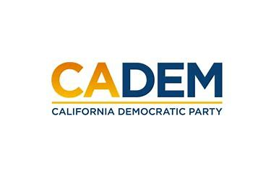

JUSTICE EQUITY DIVERSITY & INCLUSION
Executive Board Standing Committee Meeting
Co-Chairs Carolyn Fowler & Steven Auclair
February 23, 2023
5:30PM-7:00PM

ADD LINK HERE PLEASE

Agenda
I. Call to Order / Roll Call / Updates
II. Native Land Acknowledgement
III. Agenda Approval
IV. Approval of Minutes June 2022 & January 2023
Cherelle Jackson
V. Co-Chair Presentation Updates
Kareem Gongora
Shannon Ross & Marisol Rubio
Rob Howard
VI. Convention Meeting Plan
VII. DEI Presentation
VIII. Meeting Schedule Calendar
IX. Old Business
X. New Business
XI. Roundtable
XII. Adjournment

