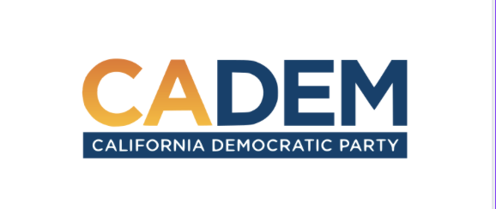

JEDI COMMITTEE
JUSTICE Minutes
September 22nd , 2022:

Meeting Called to Order: 5:35pm
Co-Chairs: Steven Auclair, Carolyn Fowler

Present Attendance: Steven Auclair, Carolyn Fowler Alfred Twu, Angela Scott, Babu Prasad , Kareem Gongora, Leah Herzberg, Li Lovett, Marilyn Cachola, Marisol Rubio, Robert Service, Wendy Bloom

Excused: Chris Bowen, Chris Wagaman, Rob Howard, Shannon Ross

Absent: Caroline Torosis, Denise Penn, Eugene Fields, Fabiola Orozco, Faye Hazar, Franky Carillo, Laniece Jones, Lisa Van Zevern, LuisAndres Perez, Mariam Ghazvini , Mark Williams, Vanessa Pimentel

Please note:
October’s Meeting Was Canceled Due to Election

Motion to accept the minutes by Tracie was Seconded by Marisol (Approved). None opposed, No extensions.
Steven Auclair: Discussed preparing for elections ahead.
Carolyn Fowler states that we will receive an e-mail of each report soon for each committee. She mentions at the last meeting that they did vote to approve a map. It will go to the Rules Committee ,and after that moved to the Executive Board meeting scheduled for November 18th-November 20th for approval.

Other notes:
Chris Bowen moved to L.A. County. He will be coming back. He’s trying to get transitioned. He’s on an interim break.

Discussion on the Governor & California For All:
Steven mentions the California For All initiatives. (He referred us to the statements sent through the chat.) Focus on health equity issues. There is movement around funding. He wanted to ensure we supported those initiatives in a very intentional way.

Marisol provides a brief overview in terms of Code of Conduct. She mentions working on making sure the new Code of Conduct going to get processed. Her, and Shannon will continue to work on that.

Carolyn talks about attending the meetings in DNC committees Rules, Labor, Women’s Caucus. She got to hear from key consultants. She discusses polling, and results as it relates to women. She emphasizes some of the organizations, and talked about there were quite a few Trumpster within some of the Unions messaging, but has since changed. Approving the delegate selection process plan.

There is talk about what location should the Convention be located for 2023. New York, Houston, Atlanta, and Chicago.

Kareem has been working on Redistricting. He’s provided updates on where we are for Redistricting. He’s thanking the JEDI committee. The Redistricting Committee did participate an open process, he had a public hearing last week. There is an approval of the Map. Paid a attention on all the submitted comments. Drafts, and documents have been sent for recommendation, and will be sent for approval at Executive Board. Thanking Marisol & Alfred as well for helping move this along.

Special Program:

Professional Development Program:
By India Compassionate Communication –Cherelle’s opinion it was a wonderful program to participate in. Thank you for putting it together.

We transitioned over to another zoom link to began the training for the rest of the evening.

Meeting Adjourned: Ended 7:00pm

