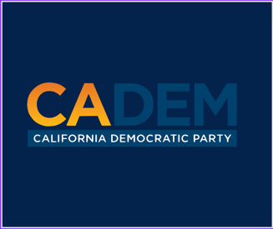

JEDI Minutes:

Meeting Called to order: 5:30pm

Motion to approve to agenda Kareem Seconded by Eugene. No objections. Agenda was adopted.

Motion to approved by Marisol seconded by Eugene. No objections.

Diane Love provides thanks for the JEDI committee. She provides information on becoming a leading force for JEDI committee, and thanks all those for the work that has done.

Carolyn Fowler provides a minute for subcommittee to give a review.

Marisol provides updates on the subcommittee. She also ran for City Counselor she discloses her experience with general election.

Discussion on updates on redistricting, and disclosure of the upcoming dates. Kareem explains and discusses final draft map. He mentions why some of the decisions were made the way they were.

A small discussion on information regarding reparations occurred.

Updates were given on the situation ongoing on in Los Angeles, and County chairs. Carolyn Fowler discusses some of her concerns.

Tracy mentions the demand for culture change, and the importance of the tough work.

Marisol mentions that some really don’t understand what equity means in regards to advocating, and reminding us about the “box analogy” see Cherelle for explanation.

India provided a training video. Training video discloses workplace scenerios such as judgement, racial bias, microaggressions, and overlooking different bias or forms of workplace harassment. Talks about finding our own voice, and use it for good. (Wonderful video).

Cherelle reflects on equity, socioeconomic status, and other intersectionality.
Marisol reflects as well on the importance of the video.
Carolyn Fowler reflects and mentions the differences.

We voted to give members rest so we did not have a JEDI Holiday Mixer.

Everyone wished each other happy holidays.

Meeting adjourned: 7:00pm PST

