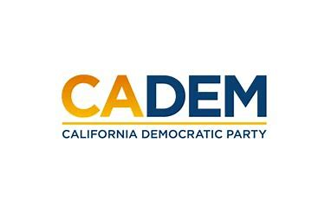

JUSTICE EQUITY DIVERSITY & INCLUSION
Executive Board Standing Committee Meeting
Co-Chairs Carolyn Fowler & Steven Auclair
January 26, 2023
5:30PM-7:00PM

RSVP: https://cadem-org.zoom.us/webinar/register/WN_s2so7tFmSBmwS410g2tO0Q

Agenda
I. Call to Order / Roll Call / Updates
II. Native Land Acknowledgement
III. Agenda Approval
IV. Approval of Minutes June & November 2022
Cherelle Jackson
V. Co-Chair Presentations
a. Redistricting: Best Practices Kareem Gongora
b. Next Step Code of Conduct: County Committee Project
Shannon Ross & Marisol Rubio
c. Leadership Training Recommendations/Who/What/Priorities
Rob Howard
VI. Meeting/Schedule Calendar
VII. Old Business
VIII. New Business
IX. Roundtable
X. Adjournment

