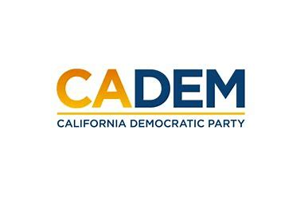

JUSTICE EQUITY DIVERSITY & INCLUSION
Standing Committee Meeting
Co-Chairs Carolyn Fowler & Steven Auclair
April 27, 2023
5:30 -7 PM

ADD LINK HERE PLEASE

Agenda
I. Call to Order / Roll Call / Updates
II. Native Land Acknowledgement
III. Agenda Approval
IV. Approval of Minutes
Cherelle Jackson
V. Co-Chair Updates
Kareem Gongora
Shannon Ross & Marisol Rubio
Rob Howard
VI. Convention Meeting Plan
VII. Meeting Schedule Calendar
X. Old Business
XI. New Business
XII. Roundtable
XIII. Adjournment

