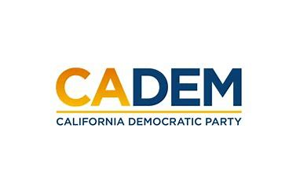

JUSTICE EQUITY DIVERSITY & INCLUSION
Executive Board Standing Committee Meeting
Co-Chairs Carolyn Fowler & Steven Auclair
March 23, 2023
5:30PM-7:00PM

(DROP IN LINK)

Agenda
I. Call to Order / Roll Call / Updates
II. Native Land Acknowledgement
III. Agenda Approval
IV. Approval of Minutes
Cherelle Jackson
V. Delegate Status/Demographic Survey
VI. Pre-Meeting Survey Shannon Ross
VII. Work Plan for Convention
VII. Meeting/Schedule Calendar
VII. Old Business
VIII. New Business
IX. Roundtable
X. Adjournment

