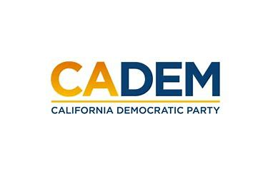

JUSTICE EQUITY DIVERSITY & INCLUSION
Standing Committee Convention Meeting
Co-Chairs Carolyn Fowler & Steven Auclair
Saturday, May 27, 2023
4 - 6 PM

Location:
This meeting is in-person, on location at the CADEM Convention at the JW Marriott in Los Angles.

Agenda
I. Call to Order / Roll Call / Updates
II. Native Land Acknowledgement
III. Agenda Approval
IV. Approval of Minutes
V. 2022-23 JEDI Accomplishments
-Sub-Committee Reports
-Training Department Updates
VI. Break Out Groups Activity

VII. Presentation on Reparations
Chris Lodgson, CJEC, the Coalition for a Just and Equitable California, and ARCC, the American Redress Coalition of California
X. Guests Speaker(s)
XI. Adjournment

